**Honor Board Accord: Fair or Foul?**

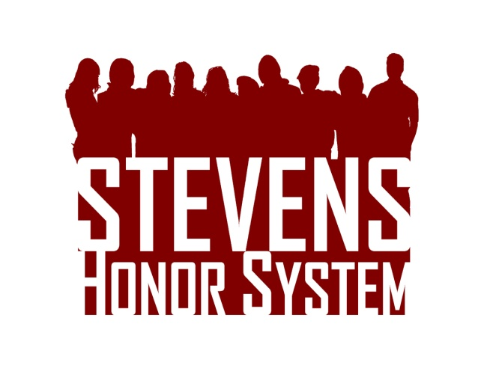Read the fake case presented to the honor board and determine whether a violation has occurred and what penalties should be assigned. Please support your reasoning. Visit [stevens.edu/honor](http://stevens.edu/honor) for the Honor System Bylaws and Penalty Matrix.  Drop your answers in Stevens mailbox S-1475 or email them to [honor@stevens.edu](mailto:honor@stevens.edu) by February 29th. The top response will receive a $50 Visa gift card!

A girl whispered to her boyfriend during a chemistry exam asking if she could borrow his calculator when he was done with it after supposedly forgetting hers in the room. The boyfriend turned in his test and then handed off his calculator. However, the calculator still displayed all the answers to the exam, answers the girl found worthy of copying. His story is that it was “an accident” and he forgot to clear his work before running off to his next class. Should any students be found guilty of an Honor System violation? If yes, what penalty should be assigned?